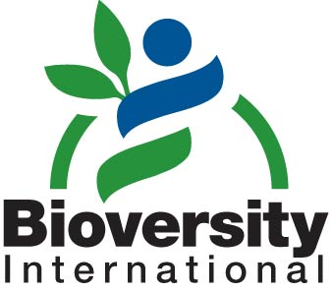
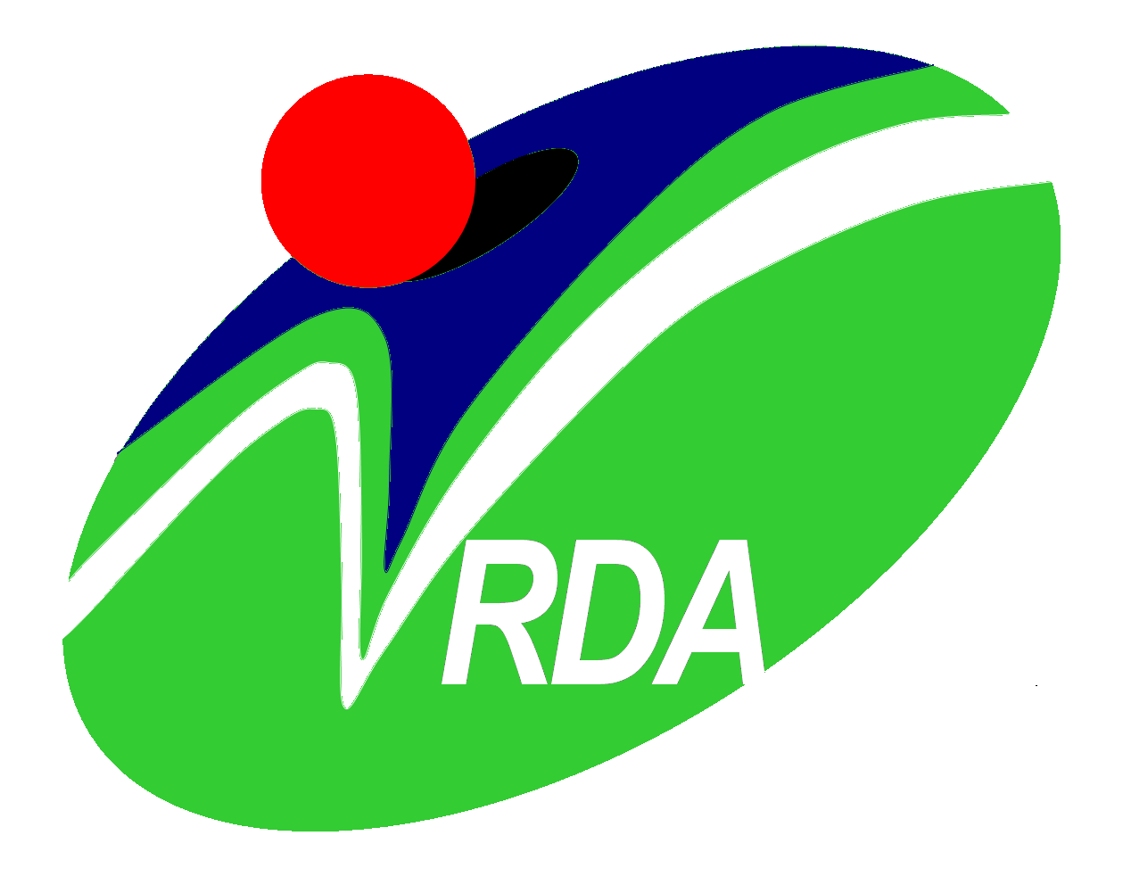
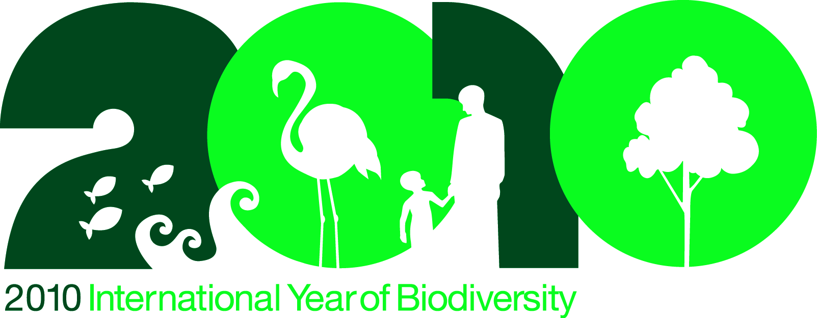
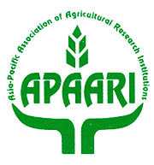

APAARI 11th General Assembly Meeting and International Symposium on Sustainable Agricultural Development and use of Agrobiodiversity in the Asia-Pacific Region

13-15 October, 2010
RDA, Suwon, Republic of Korea

Introduction
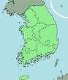 Korea is the 36th most visited country in the world. Seoul is the principal tourist destination for visitors; popular tourist destinations outside of Seoul include Seorak-san national park, the historic city of Gyeongju and semi-tropical Jeju Island. As an industrial centre, Suwon houses a large Samsung Electronics factory. Suwon is served by two motorways, the national railway network and the Seoul Metropolitan Subway, facilitating transport of commuters, tourists and goods a like.Suwon is a major educational centre, being home to 14 university campuses. This, along with wide spread transport links, draws inhabitants from across the country and foreign population of 1.85%. Suwon is known domestically as a foot balling city. Suwon Samsung Bluewings Football Club has won the K-league on four occasions.
Climate and clothing
Suwon weather in October 2010 (approximately) is as follows:
Max temperature (during the day): 20.1°C.
- Min temperature (during the night):10.1°C
- Average rainfall is 18 mm.

Clothing advice: Warm clothing like jackets and sweaters, mufflers, scarfs.

Visa

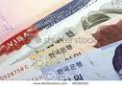 Passport holders from foreign countries require an entry visa to Korea except for nationals of those countries that have signed visa waiver agreement with the Republic of Korea.

Visas cannot be obtained upon arrival in Korea.

Until the valid Visa is obtained boarding the flight will not be allowed.

Consular Section of the Korean Embassy nearest you could be consulted to obtain information about the visa application procedure and the necessary documents required for the submission of the Visa application.

Currency

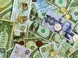 The currency is the Korean Won (KRW). The denominations are 50,000, 10,000, 5,000, and 1,000 Won. There are several coins in circulation, 500, 100, 50, and 10 popularly called the Won coins.

- Major foreign currencies could be exchanged, as there are moneychangers or banks in the city and airport. Approximately, USD 1.00 is equivalent to KRW 1160 (14th of September, 2010 Currency Exchange Rate).

From the airport
International tourists typically enter the country through Incheon International Airport, near Seoul, which was found to be the world's best airport in 2006. The participants will be greeted at the airport by the RDA staff from 10th to 11th October, 2010 and will guide participants to the respective bus stop for their respective hotels (Look for the ‘APAARI’ sign board) on arrival at the airport.
- Hotel Ramada Plaza Suwon and Hotel Castle:

Please take the airport limousine bus to Suwon. It is stationed at Bus Stop 7B (1F) of the Incheon International Airport and is available every 20 to 30 minutes from 5:30 a.m. to 10:40 p.m. Please refer to the location map at the end of the page for directions to the bus terminal at the IIA airport. Bus fare is 12,000 Korean Won (about US$ 10) and the ticket could be purchased at the ticket booth near the bus stop. Please get off the bus at the second stop for (Ramada Plaza participants) or the third stop for (Hotel Castle participants).

Please follow the route below for convenience [Hanil Town (first stop)→Ramada Plaza (second stop) →Hotel Castle (third stop)]. It usually takes about 75 minutes from IIA to the hotel.

- Hotel Dormy Inn:

Please take the airport limousine bus to Yeongtong. It is stationed at Bus Stop 7B (1F) of the Incheon International Airport and is available every 60 minutes from 7:30 a.m. to 10:30 p.m. Please refer to the location map at the end of the page for directions to the bus terminal at the IIA airport. Bus fare is 12,000 Korean Won (about US$ 10) and the ticket could be purchased at the ticket booth near the bus stop. Please get off the bus at the first stop (Seo-Suwon which is the West-Suwon bus terminal). It usually takes about 45 minutes from IIA to the destination (takes about 10 minutes from the bus stop to Dormy Inn). RDA staff will greet you at the Seo-Suwon bus stop and will provide transportation to your hotel.

Hotel accommodation

Participants will be accommodated at Ramada Plaza Suwon, Hotel Castle and Dormy Inn Suwon.

Complimentary breakfast and use of internet access are included in all three hotels.

- The delegates who wish to extend his/her stay in Korea on his/her own expense, could directly contact the designated hotels for a special booking rate well in advance for the availability of room or upon arrival at the latest.

- Transportation between the hotels and the venues will be provided by RDA, during the period of the event.

Hotel details

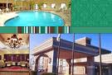

1. Ramada Plaza Suwon:
Address: 940 Ingye-dong, Paldal-gu, Suwon (5.1km to RDA, 20min)
Tel.: +82-(0)31-230-0001
Fax: +82-(0)31-230-0005
Website: http://www.ramadaplazasuwon.com
Price (special rate): KRW 150,000 (US$ 130, US$ 1=KRW 1,160), VAT 10% Exclude

2. Hotel Castle:
Address: Uman-dong, Paldal-gu, Suwon (5.8km to RDA, 20min)
Tel.: +82-31-211-6666
Fax: +82-41-545-0006
Website: http://www.onyangpalacehotel.co.kr
Price (special rate): KRW 100,000 (US $ 86, US $ 1=KRW 1,160), VAT 10% Exclude

3. Dormy Inn:
Address: 40-3 Maesanno, Paldal-gu, Suwon (2.6km to RDA, 8min)
Tel.: +82-31-888-1515
Fax: +82-41-545-0006
Website: http://dormy.webmind.kr
Price (special rate): KRW 85,000 (US $ 73, US $ 1=KRW 1,160), VAT 10% Exclude

Venue

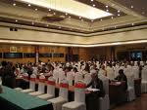 The eleventh General Assembly Meeting of the Asia-Pacific Association of Agricultural Research Institutions (APAARI) and the International Symposium on “Sustainable Agricultural Development and Use of Agrobiodiversity in the Asia-Pacific Region” will be held in Suwon and Seoul, the Republic of Korea, from 12 to 15 October 2010. The venues are:

1. Rural Development Administration

- Address: 150 Suinro,
Gwonseon-gu, Suwon 441-707
- Tel: +82-(0)31-299-2277~2279 - Fax: +82-(0)31-293 935

2. aT Center (for the 1st day of the Symposium on 13th of October)
Address: 232 Yangjae-dong,Seocho-gu, Seoul 137130
- Tel: +82-(0)2-6300-1114
- Web: http://www.atcenter.co.kr

Transportation from the respective hotel to the meeting venue and back will be arranged from 12 to 15 October 2010. Information for bus schedule from each hotel will be made available on your arrival.

Dining

During the events, lunch will be provided at the venue. Two welcome dinners, will be hosted during the event.

- First on the 12th of October (sponsored by APAARI)
- Second on the 13th of October (sponsored by RDA).

Participants with special diet preference (e.g. vegetarian, beef or pork-free dish) should inform the organiser in advance (by the end of September)

Communication



- The country code for Korea is (+82).
- The area codes for Seoul and Suwon are (02) and (03), respectively.
- For incoming calls, dial (82-2) for Seoul and (82-31) for Suwon
- For outgoing calls, you first need to dial the International Direct Dial (IDD) access code, which is 001, followed by the relevant country code (001 + country code + area code + phone number), e.g. Australia (91), so you would dial 001-91-..

Linguistic facts

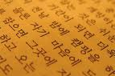 Korean is the official language of Korea. However, English is also spoken.

Time zones

Standard Time Zone of Korea is GMT+8

Health

 Emergency Services:

- Police emergency dial 112
- Emergency rescue dial 119

- The hotel could be able to recommend to a local doctor or to a pharmacy in case of emergency. Participants are however, responsible for all costs incurred.

Weights and measures

Korea uses the metric system as a system of weights and measures. Distance is calculated in kilometers and gasoline in litres.

Electricity

The electrical voltage and frequency in Korea is 220V, 60Hz as illustrated below:

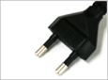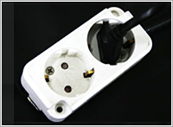

- It is recommended that participants carry an international travel adaptor/power converter.

RDA Staff

Assistance needed by guests related to transportation, courier, communication, hotel reservations or ticket reconfirmation could be provided by the RDA staff. They could be contacted on the following numbers.

Emergency contacts (RDA Staff):

1. Dr. Hong-Kil Moon, Director of International Technology Cooperation Center, RDA
Tel: +82-(0)31-299-2270, Mobile: +82-(0)10-2366-3068, E-mail: hkmoon@korea.kr

2. Dr. Gi-Hwan Yi, International Technology Cooperation Center, RDA
Tel: +82-(0)31-299-2277, Mobile: +82-(0)19-463-1974, E-mail: gihwan@korea.kr

3. Dr. Kang-Su Kwak, International Technology Cooperation Center, RDA
Tel: +82-(0)31-299-2278, Mobile: +82-(0)18-578-0617, E-mail: kskwak@korea.kr

4. Dr. Ji-Hyuk Kim, International Technology Cooperation Center, RDA
Tel: +82-(0)31-299-2279, Mobile: +82-(0)10-3080-9327, E-mail: jihyuk@korea.k

Other information


Additional information from the web:

- About Korea at http://www.korea.net/
- About Seoul at http://english.seoul.go.kr/
- About Suwon at http://eng.suwon.ne.kr/

Disclaimer

RDA, Korea disclaims all responsibility for medical, accidental and travel insurance. No compensation is provided for death, disability, loss or damage to personal property and for any other loss that may be incurred during the travel period of the participants. Therefore, it is strongly recommended to secure international medical insurance for visiting period prior to the departure.

Figure I: Location of the bus terminal at IIA

